PROJECT DOCUMENTATION
EduGenie
Google Gemini Powered Learning Assistant
An AI-powered educational assistant built with FastAPI, HTML/CSS and Google Gemini
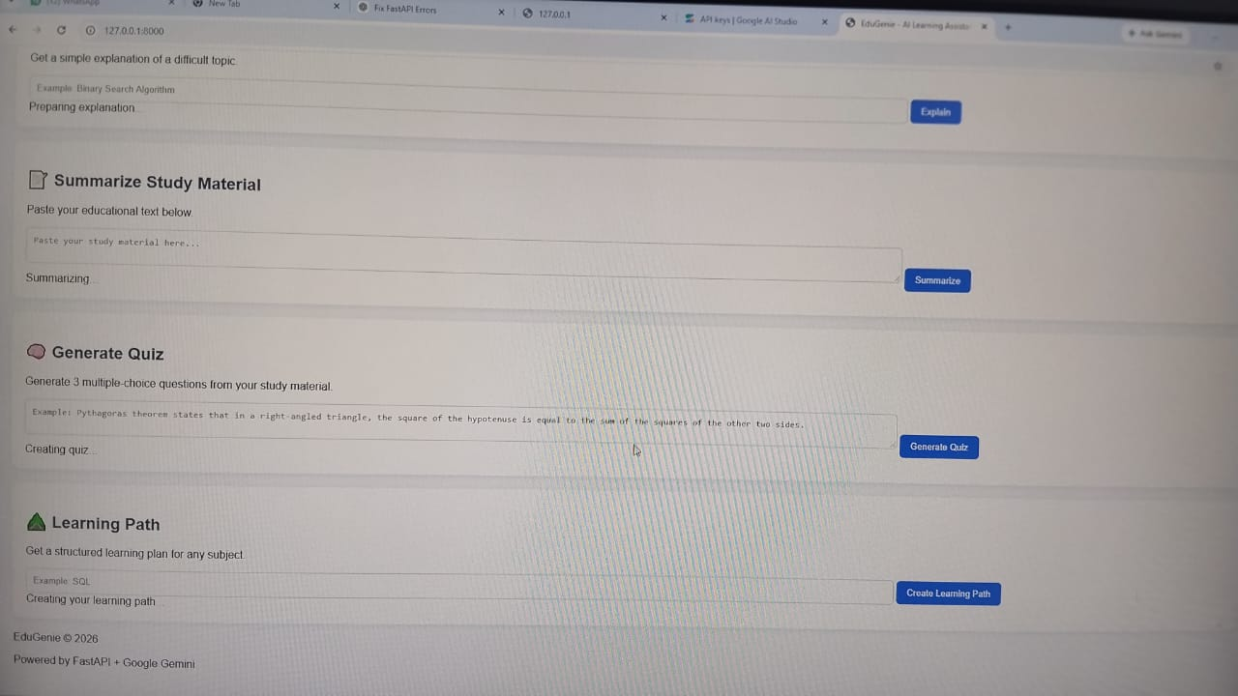
EduGenie web interface running locally at 127.0.0.1:8000
Submitted by: [Your Name]
Mentor: [Mentor Name] | Date: [DD/MM/YYYY]

Table of Contents
1. Abstract
2. Project Description
3. Objectives and Scope
4. Scenarios
5. Architectural Diagram
6. Technology Stack
7. Pre-requisites
8. Project Workflow
Milestone 1: Model Selection and Architecture
Milestone 2: Core Functionalities Development
Milestone 3: Frontend Development
Milestone 4: Deployment and Testing
9. Results and Output Screens
10. Challenges Faced
11. Future Enhancements
12. Conclusion
13. References

1. Abstract
EduGenie is a lightweight, AI-powered educational assistant that simplifies learning through generative AI. The application allows a learner to ask academic questions, receive simple explanations of difficult topics, summarize long study material, generate multiple-choice quizzes and obtain a structured learning path for any subject. All of these features are delivered through a clean web interface that runs in an ordinary browser.
The backend is built with FastAPI, a modern high-performance Python web framework, and is served locally using Uvicorn. The intelligence of the system is provided by Google Gemini, a cloud-hosted large language model that is accessed through the Gemini API. A dedicated client module (gemini_client.py) and a configuration module (config.py) keep API access, keys and model settings in one place, so that every feature module remains small, readable and easy to test.
The frontend consists of a single HTML template and a CSS stylesheet. Each feature has its own input box and action button, and the response is displayed on the same page without a reload. This documentation describes the complete development journey of EduGenie: the idea and scenarios, the architecture, the folder structure, the implementation of every module, the frontend, local deployment, functional testing, the outputs obtained, the challenges faced and the possible future improvements.

Keywords
Generative AI, Google Gemini, FastAPI, Educational Technology, Question Answering, Quiz Generation, Text Summarization, Personalized Learning Path, Prompt Engineering.

2. Project Description
EduGenie is a lightweight AI-powered educational assistant that simplifies learning through generative AI. Designed for students of all academic levels, EduGenie enables users to:
- Ask questions and receive smart, concise answers
- Understand complex concepts through simplified explanations
- Generate quizzes from topics or study text
- Receive personalized learning recommendations
- Summarize large educational passages
Built with FastAPI for the backend and a simple HTML + CSS frontend, EduGenie combines the convenience of a local web application with the power of cloud-based AI. The application starts with a single command, needs no database and can be run on ordinary laptops and desktops, which makes it accessible to a broad range of learners and developers.

2.1 Problem Statement
Students today have access to an enormous amount of learning material, yet many of them struggle to find explanations that match their level, to revise long chapters quickly, to test their own understanding and to decide what to learn next. Traditional search engines return many links but not a direct, personalised answer. General-purpose chatbots, on the other hand, are not organised around the actual tasks of a learner. EduGenie addresses this gap by offering five focused learning tools in one simple interface.

2.2 Proposed Solution
EduGenie provides five clearly separated features, each backed by its own Python module and its own API endpoint. The user picks the feature that fits the current need, types the input and receives the result immediately on the same page.
Feature | What the learner does | What EduGenie returns
Ask EduGenie | Types any educational question, e.g. "JAVA" | A clear, well-structured answer
Explain a Topic | Enters a difficult topic, e.g. "Binary Search Algorithm" | A simple, beginner-friendly explanation
Summarize | Pastes long study material | A short summary of the key points
Generate Quiz | Pastes a passage, e.g. Pythagoras theorem | Three multiple-choice questions with four options each
Learning Path | Enters a subject, e.g. "SQL" | A structured plan from beginner to advanced level

2.3 Key Advantages
- Simplicity: one page, five tools, no login and no complicated setup.
- Speed: answers are generated in seconds by a cloud model.
- Modularity: every feature lives in its own file, so it can be changed or extended independently.
- Low footprint: the heavy computation happens in the cloud, so ordinary hardware is enough.
- Secure configuration: the API key is kept in an environment file that is excluded from version control.

3. Objectives and Scope

3.1 Objectives
- To design and develop a web-based AI learning assistant using FastAPI and Google Gemini.
- To provide five learning features: question answering, concept explanation, summarization, quiz generation and learning-path recommendation.
- To keep the code modular so that every feature can be maintained and tested separately.
- To build a simple and responsive user interface that gives results in real time.
- To protect sensitive information such as the API key by using environment variables.
- To verify the application through functional testing of every feature.

3.2 Scope of the Project
EduGenie is intended for school students, college students, self-learners and educators who need quick academic support. The current version is a locally hosted web application that needs an internet connection to reach the Gemini API. It focuses on text-based interaction. Features such as user accounts, saved history, voice input and mobile applications are treated as future enhancements and are described in a later section.

3.3 Target Users
User group | How EduGenie helps
School students | Gets simple explanations and practice quizzes for exam preparation.
College students | Summarizes long notes and gets learning paths for new technologies such as SQL or Java.
Self-learners | Receives a structured plan with topics ordered from beginner to advanced level.
Teachers | Quickly creates multiple-choice questions from a passage of text.

4. Scenarios
Scenario 1 - Asking a question: A student who is learning about oceans and rivers opens EduGenie and types "Which is the largest ocean?" in the Ask EduGenie box. The system sends the question to the QnA module, which asks Gemini for a concise answer and displays it directly below the input box.
Scenario 2 - Testing understanding: A student wants to know how well she understands the Pythagoras theorem. She pastes the statement "Pythagoras theorem states that in a right-angled triangle, the square of the hypotenuse is equal to the sum of the squares of the other two sides" into the quiz section and clicks Generate Quiz. EduGenie returns three multiple-choice questions, each with four options.
Scenario 3 - Planning a learning journey: A learner who wants to explore SQL enters the subject in the Learning Path section. EduGenie returns a structured plan with beginner-to-advanced topics, timelines and suggestions for resources.
Scenario 4 - Understanding a difficult concept: A first-year computer science student is confused by the Binary Search Algorithm. Using the Explain section, the student receives a simple explanation in easy language and can continue with the quiz feature to check the understanding.
Scenario 5 - Quick revision: Before an examination, a student pastes several paragraphs of study material into the Summarize section and receives a compact version that keeps the main ideas and removes repetition.

Sample Interaction
The figure below shows a real response from EduGenie for the input "JAVA". The assistant introduces itself, explains what Java is, describes the "Write Once, Run Anywhere" principle and lists the key features of the language.
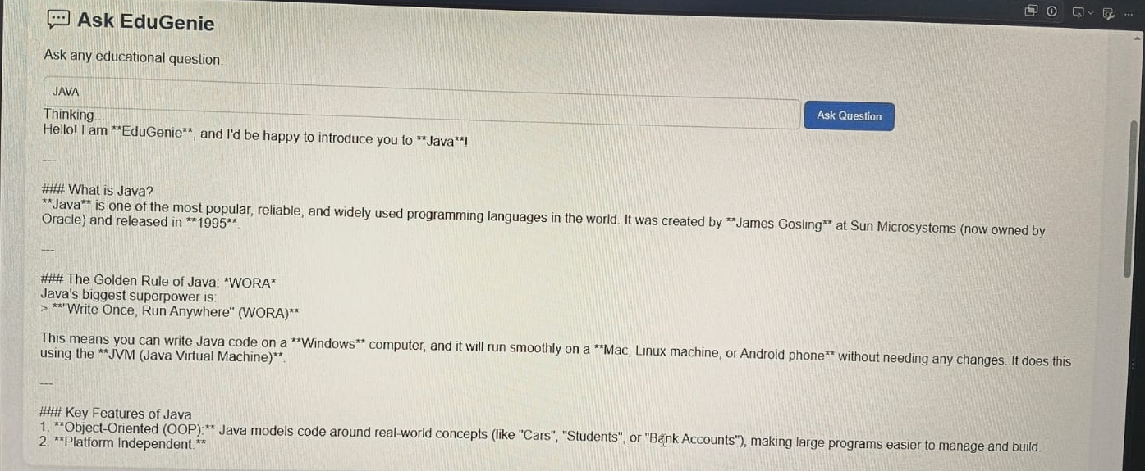
Fig. 4.1 EduGenie answering the question "JAVA"

5. Architectural Diagram
EduGenie follows a simple layered architecture. The learner interacts with the browser-based frontend. The frontend sends the request to the FastAPI backend, which forwards it to the module responsible for that feature. Each module prepares a suitable prompt and calls the shared Gemini client. The client contacts the Google Gemini API, receives the generated text and returns it up the same chain to the browser.
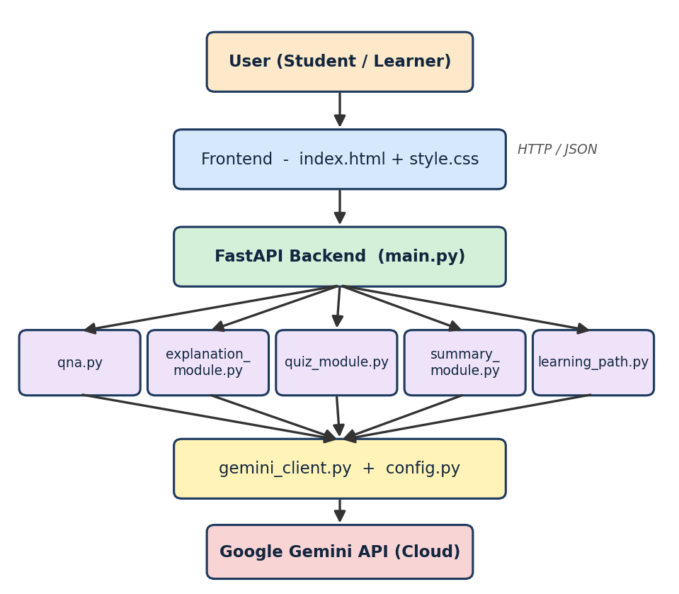
Fig. 5.1 Architecture of EduGenie

5.1 Layers of the System
Layer | Responsibility
Presentation layer | index.html and style.css: forms, buttons, loading messages and result display.
API layer | main.py: FastAPI application that defines the endpoints and serves the HTML page.
Feature layer | qna.py, explanation_module.py, quiz_module.py, summary_module.py and learning_path.py: one module per feature, each with its own prompt logic.
Integration layer | gemini_client.py and config.py: read the API key and settings, and communicate with the Gemini API.
External service | Google Gemini API: the cloud-hosted generative model that produces the answers.

5.2 Request Flow
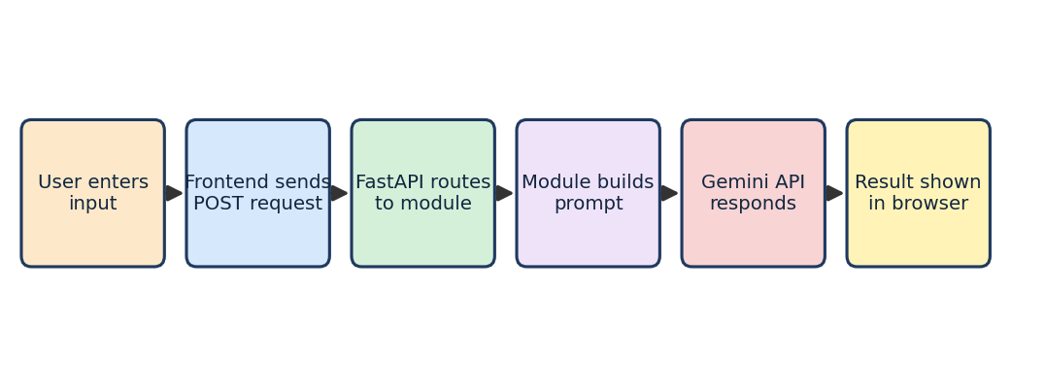
Fig. 5.2 Request and response flow
Because every feature follows this same flow, adding a new feature only requires a new module, a new endpoint and a new section in the page. No other part of the application has to change.

6. Technology Stack
Component | Technology | Purpose
Programming language | Python 3.10+ | Backend logic and all feature modules
Web framework | FastAPI | Creates the REST endpoints and serves the page
ASGI server | Uvicorn | Runs the FastAPI application with auto-reload
Templating | Jinja2 | Renders templates/index.html
AI model | Google Gemini (Gemini API) | Answers, explanations, summaries, quizzes, learning paths
Frontend | HTML5 and CSS3 | User interface and styling
Configuration | python-dotenv / .env file | Keeps the API key out of the source code
Testing | Python test files in tests/ | Automated checks for the app and the quiz module
Editor / environment | Visual Studio Code, virtual environment (.venv) | Development and dependency isolation
Version control | Git (.gitignore) | Tracks the code and excludes secrets and cache files

FastAPI was selected because it is fast, has an automatic interactive documentation page and makes it easy to define request and response formats. Google Gemini was selected because a single model can handle question answering, summarization, structured JSON output and long-form planning, which are exactly the tasks required by EduGenie.

7. Pre-requisites

7.1 Python 3.10+
- Official website: python.org (download the latest Python 3.10 or higher installer).
Installation steps:
- Download the latest Python 3.10+ installer for your operating system from the official website.
- Run the installer and make sure you tick the box "Add Python to PATH".
- Follow the installation prompts to complete the setup.
- Verify the installation by opening a terminal or command prompt and typing: python --version

7.2 FastAPI Framework
- Official documentation: fastapi.tiangolo.com
- User guide: FastAPI Tutorial
FastAPI is used to define the endpoints of EduGenie and to connect each endpoint to its module. It is installed with pip: pip install fastapi

7.3 HTML and CSS
Basic HTML and CSS knowledge is needed to understand the templates/index.html page and the static/style.css stylesheet used for the interface.

7.4 Google Gemini API Key
- Official documentation: Google AI for Developers
Setup steps:
- Visit Google AI Studio and sign in with your Google account.
- Open the API keys page and create a new API key.
- Copy the key and store it securely.
- Paste the key into your local .env file. Never upload the real key to GitHub.

7.5 Uvicorn (ASGI Server)
Uvicorn runs the FastAPI application. Install it with: pip install uvicorn

7.6 Jinja2 (HTML Templating Engine)
Jinja2 is used by FastAPI to render the HTML template. Install it with: pip install jinja2

7.7 Installing All Dependencies
All required libraries are listed in requirements.txt. After creating and activating a virtual environment, they can be installed together with one command: pip install -r requirements.txt.

8. Project Workflow
The project was completed in four milestones: model selection and architecture, core functionality development, frontend development, and deployment with testing.

MILESTONE 1: Model Selection and Architecture

Activity 1.1: Select the AI Model
Google Gemini, accessed through the Gemini API, was chosen as the AI engine of EduGenie. All requests are sent through one shared file, gemini_client.py, so the model and its settings can be changed in a single place.
- Used for: question answering, concept explanation, summarization, quiz generation and learning paths.
- Benefits: advanced reasoning, well-structured output, the ability to return JSON for quizzes, and cloud inference that does not need a powerful local machine.

Activity 1.2: Design the Folder Architecture
The project is organised into small files with clear responsibilities. The folder structure of EduGenie is shown below.
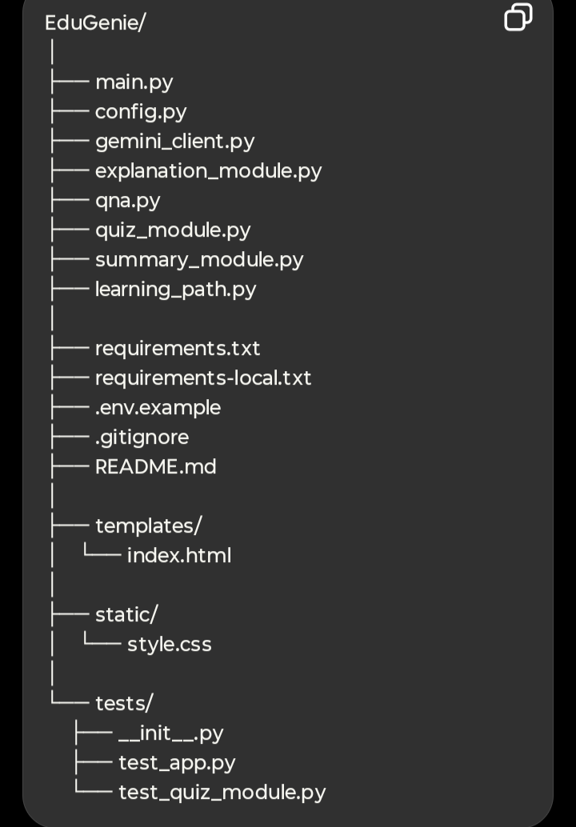
Fig. 8.1 Folder structure of EduGenie

Description of the Files
File / Folder | Purpose
main.py | FastAPI application: creates the app, serves the page and defines all API endpoints.
config.py | Loads the API key and settings from the environment.
gemini_client.py | Shared client that sends prompts to Google Gemini and returns the response.
explanation_module.py | Concept explanation logic.
qna.py | Question answering logic.
quiz_module.py | Multiple-choice quiz generation and JSON cleaning.
summary_module.py | Summarization of long study material.
learning_path.py | Learning-path recommendation logic.
requirements.txt | Python dependencies of the application.
requirements-local.txt | Extra dependencies for local development and testing.
.env.example | Template that shows which environment variables are needed, without real secrets.
.gitignore | Prevents the .env file, .venv and cache files from being committed.
README.md | Project introduction and run instructions.
templates/index.html | HTML frontend of the application.
static/style.css | Styling of the interface.
tests/ | Test package: __init__.py, test_app.py and test_quiz_module.py.

MILESTONE 2: Core Functionalities Development

Activity 2.1: Module Implementation

1. Configuration and Gemini Client
config.py reads the Gemini API key from the environment (the .env file) so that no secret is ever written in the source code. gemini_client.py uses this key to create a connection to Google Gemini and exposes one simple function that every module uses to send a prompt and receive text. Because all modules share this client, a change of model or a change in error handling has to be made only once.

2. Question Answering (QnA) Module
The QnA module, in qna.py, handles general knowledge and academic questions. It receives the question from the endpoint, wraps it in a prompt that asks for a clear and educational answer, and sends it to Gemini. The reply is returned to the frontend. When the user typed "JAVA" in the Ask EduGenie box, the assistant produced a complete introduction with headings, the history of the language, its guiding principle "Write Once, Run Anywhere" and a list of key features, as seen in the output section of this document.

3. Explanation Module
The explanation module, in explanation_module.py, is used for the "Explain a Topic" feature. The prompt instructs the model to explain a difficult topic in simple language, using short sentences and everyday examples, so that learners with little background knowledge can follow. A topic such as "Binary Search Algorithm" is therefore explained in a way that is suitable for beginners, school students and self-learners.

4. Quiz Module
quiz_module.py generates three multiple-choice questions from a passage entered by the user. Each question has four options and one correct answer. The prompt asks Gemini to return the result as valid JSON so that the frontend can display it easily. Because language models sometimes wrap JSON inside Markdown code fences, the module includes a cleaning step that removes such fences before parsing the text into a Python list. If generation or parsing fails, a clear error message is returned, which makes debugging easier. This module has its own automated test file, test_quiz_module.py.

5. Summary Module
summary_module.py uses Gemini to convert long paragraphs into short, easy-to-read summaries. The prompt asks the model to keep the core information, remove repetition and keep the language simple. This is ideal for quick revision because the learner can absorb the key points without reading the entire text again.

6. Learning Path Module
learning_path.py generates a personalised and structured learning path for any subject. The prompt asks the model to arrange topics from beginner to advanced level, to suggest a suitable timeline and to recommend resources such as videos, articles and books. The function handles the API response safely and returns either the generated plan or a helpful error message when the response is invalid or incomplete.
Module | Input | Output
qna.py | A question (text) | Answer text
explanation_module.py | A topic name | Simple explanation text
quiz_module.py | A study passage | 3 MCQs with 4 options each (JSON)
summary_module.py | Long study text | Short summary text
learning_path.py | A subject name | Structured beginner-to-advanced plan

Activity 2.2: Backend API with FastAPI
main.py creates the FastAPI application, serves the HTML page and defines one endpoint for each module. Each endpoint receives the user input, calls the corresponding module and returns the result to the browser.
Endpoint | Method | Description
/ | GET | Serves the EduGenie web page (templates/index.html).
/qa | POST | Answers a general or academic question.
/explain | POST | Explains a topic in simple language.
/quiz | POST | Generates three multiple-choice questions from a passage.
/summarize | POST | Summarizes long study material.
/learn/recommendations | POST | Creates a structured learning path for a subject.

FastAPI also produces interactive API documentation automatically, which can be opened in the browser at /docs and used to test every endpoint without writing any frontend code.

MILESTONE 3: Frontend Development

Activity 3.1: Build the Web Interface
The user interface is a single page, templates/index.html, styled by static/style.css. The page is divided into five card-style sections, one for each feature. Every section has a heading with an icon, a short description, an input box and an action button.
- Ask EduGenie: a text box and the "Ask Question" button.
- Explain a Topic: a text box with the placeholder "Example: Binary Search Algorithm" and the "Explain" button.
- Summarize Study Material: a large text area with the placeholder "Paste your study material here..." and the "Summarize" button.
- Generate Quiz: a text area for the passage and the "Generate Quiz" button.
- Learning Path: a text box with the placeholder "Example: SQL" and the "Create Learning Path" button.

CSS Styling (style.css)
- Clean card layout with a soft background and clear spacing between sections
- Blue rounded action buttons that are easy to identify
- Readable input boxes and text areas with helpful placeholder text
- A result area below every input box that displays the response
- A footer that reads "EduGenie 2026 - Powered by FastAPI + Google Gemini"
Fig. 8.2 Frontend of EduGenie showing the Explain, Summarize, Quiz and Learning Path sections

Activity 3.2: Live Integration
- When a button is clicked, the form data is sent as a POST request to the matching FastAPI endpoint.
- While the server is working, a status message such as "Thinking...", "Preparing explanation...", "Summarizing...", "Creating quiz..." or "Creating your learning path..." is shown to the user.
- When the response arrives, the result appears below the input box in real time, without reloading the page.
These loading messages can be seen in the screenshot above and improve the user experience because the learner always knows that the request is being processed.

MILESTONE 4: Deployment and Testing

Activity 4.1: Run Locally
EduGenie is deployed locally. After the virtual environment is activated and the dependencies are installed, the application is started with Uvicorn:
uvicorn main:app --reload
The --reload option restarts the server automatically whenever a file is changed, which is very convenient during development. The application is then opened in the browser at http://127.0.0.1:8000.

Environment Setup Summary
- Create a virtual environment (.venv) and activate it.
- Install the libraries with pip install -r requirements.txt.
- Copy .env.example to .env and add your Gemini API key.
- Start the server with uvicorn main:app --reload.
- Open http://127.0.0.1:8000 in a web browser.

Activity 4.2: Functional Testing
Every feature was tested manually through the browser, and the application and quiz module also have automated test files in the tests folder (test_app.py and test_quiz_module.py). The following table summarises the functional test cases.
No. | Feature tested | Test input | Expected result
1 | Ask a question | JAVA | Structured introduction to Java
2 | Explain a topic | Binary Search Algorithm | Simple explanation in easy language
3 | Summarize content | Pasted study paragraph | Short summary of the key points
4 | Generate a quiz | Pythagoras theorem statement | 3 MCQs with 4 options each
5 | Learning path | SQL | Beginner-to-advanced plan
6 | Loading message | Click any button | Status text shown while waiting
7 | Home page | Open 127.0.0.1:8000 | EduGenie page loads successfully

All test cases produced the expected results, confirming that every layer works together correctly.

9. Results and Output Screens
This section presents the output of EduGenie for each of its features.

a. Asking Questions
The user typed the topic "JAVA" into the Ask EduGenie box and clicked Ask Question. After the "Thinking..." message, EduGenie displayed a friendly, structured answer.
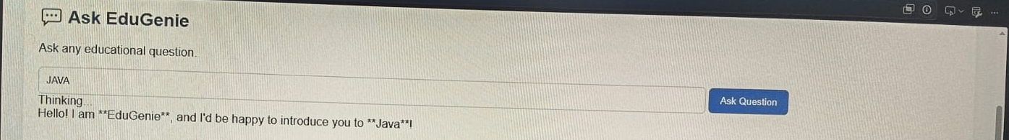
Fig. 9.1 Ask EduGenie: question input and the beginning of the answer
The answer starts with a greeting and explains that Java is one of the most popular, reliable and widely used programming languages, created by James Gosling at Sun Microsystems and released in 1995.
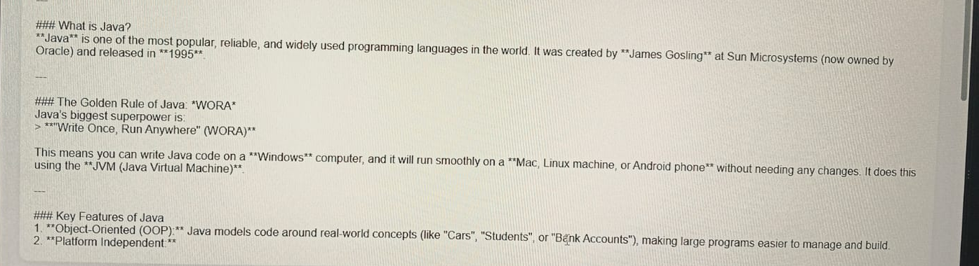
Fig. 9.2 Detailed answer with headings, quotation and numbered key features
The response continues with the golden rule of Java, "Write Once, Run Anywhere" (WORA), which means that Java code written on Windows can run on Mac, Linux or Android using the Java Virtual Machine. It then lists key features such as object-oriented programming and platform independence.

b. Explanation of a Topic
In the Explain section, the learner enters a topic such as "Binary Search Algorithm". While the model works, the message "Preparing explanation..." is displayed. The result is a simple and easy-to-follow explanation of the topic.
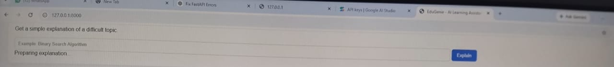
Fig. 9.3 Explain a Topic section

c. Summarizing Long Paragraphs
The learner pastes the study material into the large text area and clicks Summarize. The status message "Summarizing..." appears and the shorter version of the text is shown below.

Fig. 9.4 Summarize Study Material section

d. Generating Quizzes
The quiz section is pre-filled with the example passage about the Pythagoras theorem. After clicking Generate Quiz and seeing the message "Creating quiz...", the learner receives three multiple-choice questions with four options each and can check the correct answers.

Fig. 9.5 Generate Quiz section

e. Learning Recommendations
For a subject such as SQL, EduGenie builds a structured learning path from beginner to advanced level. The message "Creating your learning path..." is shown while the plan is prepared. The result guides the learner step by step through the topics.

Fig. 9.6 Learning Path section

f. Development Environment
The project was developed in Visual Studio Code with a virtual environment. The application was run with Uvicorn, and the EduGenie page was previewed inside the editor, which allowed quick testing after every change.

10. Challenges Faced
The development of EduGenie brought several practical challenges. Each challenge helped to improve the design and taught valuable lessons.
Challenge | Explanation | Solution
Accuracy of AI responses | Generated answers must be correct and suitable for learners. | Careful prompt design and repeated testing with different topics.
Structured quiz output | The model may wrap JSON in Markdown or return an invalid format. | A cleaning function and safe parsing with clear error messages.
API key security | Secret keys must never be published. | Use of a .env file, .env.example template and .gitignore.
API and server errors | Network problems or invalid responses can break a feature. | Error handling in the client and in every module.
User experience | Users should not feel that the page is frozen. | Loading messages and results shown on the same page.
Response formatting | Markdown symbols such as ** and ### appear in plain text output. | Planned improvement: render Markdown as formatted HTML in the frontend.

These challenges gave valuable learning outcomes, especially in prompt engineering, cloud API integration, error handling, secure configuration and user-centred design.

Learning Outcomes
- Building a REST API with FastAPI and connecting it to a frontend.
- Writing effective prompts for different tasks such as answering, summarizing and quiz generation.
- Working with structured JSON output from a language model.
- Organising a Python project into modules and writing tests.
- Protecting secrets with environment variables and .gitignore.

11. Future Enhancements
EduGenie is a strong foundation, and there are many directions in which it can grow.
- Voice interaction: speech input and spoken answers for hands-free learning and better accessibility.
- Multilingual support: answers in regional and international languages to reach a wider audience.
- Formatted output: proper rendering of Markdown headings, lists and quotations in the answer area.
- Mobile application: a mobile app so that learners can study anytime and anywhere.
- Progress tracking: dashboards with learning history, quiz scores and improvement graphs.
- Gamification: badges, learning streaks and challenge-based assessments to improve motivation.
- Adaptive learning paths: paths that change according to the strengths and weaknesses of the learner.
- Interactive quizzes: scoring, instant feedback and explanations of the correct answers.
- Image and PDF input: snapshot-based doubt solving and summarization of uploaded documents.
- Collaboration: group study sessions and dashboards for teachers and parents.
- LMS integration: connection with platforms such as Moodle or Google Classroom.
- Cloud deployment: hosting the application online so that anyone can use it through a public link.

12. Conclusion
EduGenie has been developed as a robust and accessible AI-powered educational assistant that combines cloud-based intelligence with an intuitive, low-footprint web interface. Designed to support self-learners, students and educators, EduGenie simplifies complex concepts, provides instant question-and-answer interaction, generates quizzes, offers concise summaries and creates learning paths tailored to a subject.
Throughout the development, the project achieved its key milestones in model selection, backend development with FastAPI, frontend design and local deployment. The modular structure, in which every feature has its own file and the Gemini access is kept in a single client, makes the code easy to understand, test and extend. The output screens show that the application answers questions, explains topics, summarizes text, generates quizzes and prepares learning paths successfully.
The development journey also had challenges such as ensuring the accuracy of AI-generated responses, handling structured output, protecting the API key and creating a smooth user experience. Overcoming them through continuous testing, prompt refinement and careful configuration provided valuable experience in prompt engineering, cloud integration and scalable software design.
Looking ahead, EduGenie has great potential for enhancement through voice interaction, multilingual support, mobile access, progress tracking, gamification and integration with learning management systems. In conclusion, EduGenie is not just an AI tool; it is a foundation for the future of personalised, inclusive and intelligent education. As it continues to evolve, it can become a comprehensive learning companion for the modern era: smart, scalable and learner-first.

13. References
- Google AI for Developers - Gemini API and API keys: https://ai.google.dev/gemini-api/docs/api-key
- Google AI Studio: https://aistudio.google.com
- FastAPI documentation: https://fastapi.tiangolo.com/
- FastAPI tutorial: https://fastapi.tiangolo.com/tutorial/
- Uvicorn documentation: https://www.uvicorn.org/
- Jinja2 documentation: https://jinja.palletsprojects.com/
- Python downloads: https://www.python.org/downloads/
Submitted by:
[Your Name]
Mentor: [Mentor Name]
Date: [DD/MM/YYYY]

